Quantifying synchrony and variability in source water quality across nested catchments of a protected second growth forested water supply area

Hannah J. McSorley

April 2020

Table of Contents

# Abstract (max 350 words) - roman numeral TOC

This research contributes to understanding the “natural” variability in DOM and DOC across a forested riverine watershed: the Leech River watershed on Vancouver Island, British Columbia, Canada. Land-use impacts are minimal in this research area as 96% of the watershed is protected as drinking water supply area (Leech Water Supply Area). Like most forested areas on Vancouver Island, the Leech watershed is second-growth softwood forest with a history of extensive harvest (nearly 96% cleared).

The purpose of this master’s research project was to establish a baseline understanding of hydrologic responses and water quality variability in rivers across the LWSA. The approach includes advanced synoptic sampling within stormflow, supplemented with standard grab samples between storm events and during summer baseflow. Discrete samples of river water were collected passively during the rising limb of stormflow (falling limb prototype in progress) using low-powered, low-cost, custom-built vertical rack samplers including water level loggers (Odyssey) and observational reference staff gauges. By collecting samples during stormflow, a more robust understanding of water quality dynamics was achieved than basic grab sampling alone. Using low-powered passive sampling techniques allowed for multiple (six) sites to be equipped with monitoring/sampling racks, providing fairly good spatial resolution of hydrochemical variability across the watershed.

# Lay Summary (max 150 words) - roman numeral TOC

include plain-language summary

# Preface - roman numeral TOC

see: <https://www.grad.ubc.ca/sites/default/files/doc/page/thesis_sample_prefaces.pdf>

*TOC follows, then LOT, LOF, List of Illustrations, list of abbreviations

# Acknowledgments

This research work would not have been possible without the support and accommodation of the Capital Regional District (CRD) Watershed Protection and Management Division, Integrated Water Services (IWS) (Victoria, BC). I would like to acknowledge the help, support and assistance provided by the following CRD people: Tobi Gardner, Annette Constabel, Kathy Haesevoats, Joel Ussery, Ryan Biggs, Patrick McCoubrey, Burn Hemus, Christoph Moch, Jessica Dupuis, and Devon Barnes.

I’m grateful to have been supported by the entire CRD Field Operations Staff, thanks for making me feel welcome and included on site.

This research also would not have been possible without the support and encouragement from academic supervisors and partners from the NSERC forWater Network for Forested Drinking Water Source Protection Technologies: Bill Floyd, Mark Johnson, Suzanne Tank, Mike Stone, Dana Harriman, Monica Emelko, Uldis Silins, Axel Anderson.

For help with field installations and streamflow gauging, a big thanks to my former field partner, Stewart Butler, of Bill Floyd’s Coastal Hydrology Research Lab; thanks Stew. Thanks also to Alison Bishop for field assistance during the winter of 2019/2020.

Last but certainly not least, thanks to my wonderful friends and family for supporting me in my scientific and academic pursuits. I really appreciate all the love and support, bike rides and beers, proof-reading and encouragement.

# Dedication

To each person who reads this thesis in its entirety.

For the love of data science, I am grateful for Jenny Byran’s online resources, StackOverflow (<http://stackoverflow.com>) for the solution to so many coding challenges. Thank you to RStudio for making a functional and friendly IDE for the R programming language and to GitHub for making version control streamlined and reproducible. Cheers to Hadley Wickham for the tidyverse and Yihui Xie for the bookdown package (in which I generated this thesis).

“Not only is it vital to all biological functions on earth, water links abiotic and biotic, connects the earth to the atmosphere, and creates a dynamic fluid continuum between ecosystems.” ~ Hannah McSorley

# 1 Introduction

## 1.1 Forested source water supplies and drinking water treatment

Surface water is the primary source of drinking water for over 85% of the Canadian population and in the province of British Columbia, approximately 80% of drinking water originates from forested headwaters (Pike et al. 2010). Forests offer a variety of ecosystem services (e.g. biodiversity) and also slow and filter runoff, resulting in high quality source water supply (Dudley and Stolton 2003). Surface water quality varies over time and space due to climate, weather, and physical characteristics of the watershed (such as topography, land cover and geology), and runoff processes introduce terrestrial material, sediments, nutrients, and organic matter to surface water (Pike et al. 2010; Johnson et al. 1997; Delpla and Rodriguez 2016; Health Canada 2019; Yang et al. 2015).

In Canada, all drinking source water is treated to meet Health Canada drinking water quality guidelines, which specify allowable levels of biological, physical and chemical parameters that are safe for human use and consumption (British Columbia Ministry of Environment 2017). Drinking water treatment processes vary from simple chlorination to multiple stages of chemically assisted filtration in combination with advanced oxidative processes. Water treatment protocols differ between communities based on source water quality, infrastructure capabilities, budget, and regional water quality regulations [!!REFS]. Chlorination remains the most widely used method of inactivating potentially harmful microorganisms, whether it stands alone as the primary and sole treatment protocol, or is used in combination with other processes (HealthCanada 2006; HealthLinkBC 2018).

When natural source water is chlorinated, chemical reactions with natural organic matter (NOM) can form a variety of chlorinated organic compounds which are broadly classified as disinfection byproducts (DBPs) (Richardson et al. 2007; Delpla and Rodriguez 2016; Health Canada 2019; Yang et al. 2015; Hua, Reckhow, and Abusallout 2015; Eaton, A. D., Clesceri, L. S., Greenberg, A. E., Franson 2000). A number of DBPs are included in Health Canada’s drinking water quality guidelines, and have maximum allowable concentrations in treated water due to their potential or known health affects (i.e., genotoxicity and carcinogenicity) (Richardson et al. 2007; British Columbia Ministry of Environment 2017).

## 1.2 Aqueous natural organic matter

Source water treatability varies with Natural organic matter (NOM) concentration and character, which depend on source material, hydrology, and biogeochemical factors (Aiken, Hsu-Kim, and Ryan 2011; Abbott et al. 2018; Zarnetske et al. 2018). Molecular composition and physical structure influence NOM reactivity, therefore different types of aqueous NOM have different disinfection byproduct formation potentials (DBP-FPs) (Delpla and Rodriguez 2016; Yang et al. 2015; Health Canada 2019; Chow et al. 2008). NOM comprises a dynamic collection of molecules from a variety of sources, and aqueous NOM exists in complex and diverse combinations of particulate, colloidal and dissolved fractions. NOM can be introduced to a water body from terrestrial sources or generated through in-stream processes which are often associated with autotrophic organisms like algae and cyanobacteria (autochthonous NOM). Terrestrial organic matter (allochthonous NOM) includes humic and fluvic acids, tannins, and a wide variety of other compounds (e.g. phenols and lignin, hydrocarbons, proteins, carbohydrates, etc.), which enter fresh water through runoff processes (Zarnetske et al. 2018; Health Canada 2019).

NOM molecules contain nitrogen, silica, oxygen and hydrogen but are composed primarily of organic carbon; thus, organic carbon is often measured as a proxy for NOM concentration (Health Canada 2019). Total organic carbon (TOC) is operationally divided into particulate and dissolved fractions (POC and DOC, respectively) which are typically distinguished based on separation by a 0.45-micron filter (Eaton, A. D., Clesceri, L. S., Greenberg, A. E., Franson 2000; Aiken, Hsu-Kim, and Ryan 2011). Generally, DOC is the predominant fraction of aqueous TOC, and the amount of DBPs in treated water is proportional to raw water DOC concentration (Weishaar et al. 2003; Chow et al. 2008). As DOC is likely to generate DBPs during chlorination, it is an important source water quality parameter to monitor. In fact, guidelines in British Columbia specify that source water TOC should remain below 4 mg/L to reduce DBPs in treated drinking water (British Columbia Ministry of Environment 2017).

In addition to acting as a precursor for DBPs, NOM has the ability to bind and transport contaminants in solution (e.g. metals, organic pollutants, nutrients) and influences stream pH, as well as aquatic light and temperature regimes (Oni et al. 2013; Aiken, Hsu-Kim, and Ryan 2011; Weishaar et al. 2003; LaZerte 1991; Palleiro et al. 2013; Stanley et al. 2012). NOM is an energy source for aquatic heterotrophic microbes (Stanley et al. 2012) and as such, could contribute to biofouling of water supply and treatment infrastructure (which could lead to service disruptions). DOC has been called a “master variable” due to it’s terrestrial-aquatic linkages, influence on water chemistry and role in contaminant transport (Zarnetske et al. 2018). Within a watershed, the characteristics and concentrations of NOM (and therefore DOC) naturally fluctuate over space and through time, creating dynamic treatability conditions (Li et al. 2014, @Yang2015).

## 1.3 Watershed processes and water quality

Streams are intrinsically linked to their watersheds through dynamic biotic-abiotic interactions and hydroclimatic relationships; as a result, aqueous biogeochemicals represent an important link between ecosystem processes, hydrology, and water resources. Biogeochemical signatures are useful tracers to better understand catchment processes and regional hydrology, as they are indicative of flow paths, sources, chemical origins and transport pathways (Abbott et al. 2018; Meyer and Tate 1983; Vidon, Wagner, and Soyeux 2008; Rautu 2019). The origins, transport and fate of biogeochemicals in source waters is important for drinking water treatment, because the quality of source water (physiochemical composition and concentrations) governs treatment requirements and largely dictates the quality of treated water, particularly with respect to disinfection byproducts (Weishaar et al. 2003; Chow et al. 2008).

Water quality parameters exhibit natural variability across a river network due to dynamic biotic and abiotic interactions. For example, the river continuum concept (RCC) predicts a temporal shift in DOM character, including seasonal shifts between autotrophic generation of NOM and heterotrophic processing of detritus (i.e. autochthonous to allochthonous DOM) (Vannote et al. 1980; Meyer and Tate 1983). The RCC also predicts a spatial reduction in DOM molecular diversity from headwaters (entry point for majority of solutes) to river mouth (i.e., reduced DOM diversity from low to high order streams) (Vannote et al. 1980; Mosher et al. 2015; Abbott et al. 2018; Creed et al. 2015). The longitudinal attenuation of DOM diversity can be explained by a combination of hydrological processes; geomorphic variables and physical impoundments; organic matter inputs and sources; sediment transport; solar inputs; and processing by aquatic invertebrates and microbes (Vannote et al. 1980; Stanley et al. 2012; Aiken, Hsu-Kim, and Ryan 2011; Zarnetske et al. 2018).

On a finer temporal scale, hydrologic pulses can cause temporal variability in DOM characteristics; for example, the character of DOM has been shown to vary during hydrologic response to precipitation, which indicates a change in DOM source over the course of an event (Vidon, Wagner, and Soyeux 2008; Abbott et al. 2018). The Pulse Shunt Concept (PSC) supplements the temporal aspects of RCC by considering how major hydrologic events drive regional DOM metabolism and the magnitude, timing and spatial extent of DOM flux (Raymond et al. 2016). While the link between mobilization of source material and biogeochemical processes govern the character of aqueous NOM, the PSC shows that it is hydrologic processes that govern NOM concentrations in streams (Abbott et al. 2018; Creed et al. 2015; Zarnetske et al. 2018). Where the RCC relies on in-stream biogeochemical processing to explain longitudinal alteration of NOM character, intense hydrologic pulses (related to precipitation or melt events) override the rate of biogeochemical processing and force mass transport events. Discharge determines the magnitude of DOC flux (i.e., concentration transport) and under pluvial regime, precipitation and discharge are the primary controls on stream DOC concentrations (Zarnetske et al. 2018; Vidon, Wagner, and Soyeux 2008). Indeed, brief flood events are often responsible for the majority of fluvial DOC transport in a watershed (Raymond et al. 2010).

Through a large and geographically diverse data study in the United States, Zarnetske *et al* (2018) found that increasing flows systematically increased DOC fluxes in 80% of watersheds (n=1006) across ecoregions. Proportional increases in DOC flux and discharge indicates that the flux is not limited by organic matter supply, but rather by hydrologic connectivity and mobilization (Creed et al. 2015; Zarnetske et al. 2018). Watershed size and stream order were determined to be weak indicators of DOC flux-discharge relationship while watershed slope and mean precipitation were strong predictors of DOC flux (Zarnetske et al. 2018). Zarnetske *et al* (2018) also found that wetland area exerted non-linear control over whether DOC flux was limited by supply or hydrologic transport.

Aspects of both the RCC and PSC were illustrated in a recent nested catchment study by Abbott *et al* (2018) which found greater DOM chemical diversity in headwaters relative to downstream, but not greater temporal variance in headwaters biogeochemistry. Despite longitudinal differences in molecular character, solute concentrations varied synchronously among upstream and downstream sites, leading to temporal stability in relative biogeochemical signatures (Abbott et al. 2018). The temporal extent to which water quality changes echo across nested subcatchments depends on the synchrony (i.e. mean covariance) of the hydrologic pulse generation among subcatchments (Abbott et al. 2018).

## 1.4 forWater & CRD GVWSA

### 1.4.1 The forWater NSERC Strategic Network for forested drinking water source protection technologies

The NSERC Strategic Network, forWater, is a transdisciplinary cross-Canada applied research collaboration focused on the connections between treated drinking water quality and land-use impacts of forest management. The majority of source drinking water originates in forested headwaters, but the connection between upstream forest management and downstream treatment remains poorly understood. forWater researchers are studying water quality in watersheds across Canada, under a variety of different forest management strategies. Through collaborative analyses, forWater is working to evaluate source water treatability metrics, downstream propagation effects, and resource economic with the ultimate goal of providing a framework for treatement demands.

Forest management and landscape disturbances can ultimately effect water treatability by altering material inputs, biogeochemical processes and stream ecology, as well as changing preferential flow-paths and the mobilization, transport and dilution of biogeochemcial components (Meyer and Tate 1983). It has been shown that, two to three years post-harvest, baseflow DOC concentrations were higher in forested catchments than in clear-cut catchments; however, these studies also showed variable stormflow DOC responses in harvested and forested catchments (Meyer and Tate 1983; Mistick 2019). In the absence of long-term baseline data (i.e., pre- and post-disturbance data sets), the natural variability in fluvial processes complicates land-use studies and anthropogenic climate change can further confound our interpretations. Overall, DOC trends related to land-use seem highly dependent on catchment attributes and hydrologic forces. High intensity and/or long duration precipitation events can deplete both terrestrial and aquatic NOM storage sources (e.g. high flows can disturb benthic NOM storage) (Meyer and Tate 1983). Understanding the hydrochemistry of a water supply area is key to conducting informed preventative forest management applications.

### 1.3.2 Greater Victoria Water Supply Areas

The Capital Regional District, a forWater Partner, is committed to the multiple barrier approach to clean drinking water and has taken control of source water protection by purchasing and privatizing the water supply areas for Greater Victoria. Located on southeastern Vancouver Island, British Columbia, the Greater Victoria Water Supply Area (GVWSA) includes 20,549 hectares (205.49 km2) of protected drinking water catchment lands. Currently, Greater Victoria’s water supply is sourced from five surface water reservoirs in the Sooke and Goldstream watersheds. In 2007 and 2010, the CRD purchased and additional 96.28 km2 (9,628 hectares) of land which included the majority of the Leech River watershed (a major sub-catchment of the Sooke River watershed). In anticipation of future water demands, this area was designated as a supplemental water supply for Greater Victoria: the Leech Water Supply Area (LWSA). In the future (possibly by 2050), inter-basin transfer will supplement the primary drinking water supply by moving Leech River water through a diversion tunnel to Sooke Reservoir. Approximately 92% of the Leech River watershed above the point of diversion (Leech Tunnel) is protected as WSA.

Overall, the hydrology of the LWSA is poorly understood, as are water quality dynamics. In the mid-1980’s, some water was transfered from the Leech River into Deception Gulch and Reservoir (adjacent to but physically separated from Sooke Reservoir). The mixing resulted in biological water quality problems that included odour and raised concerns about the operational usage of the existing tunnel. The Leech River Tunnel and anticipated inter-basin transfer will provide many interesting research opportunities. Before work is done on inter-basin transfers, the hydrology and water quality of the Leech River system need to be better understood. Understanding source water quality, as well as the timing and magnitude of flows, is an essential component to multiple barrier approach to ensuring clean drinking water.

#### 1.3.2.1 Forest management

The LWSA was privately managed forest land which was extensively harvested over the past 70 years (nearly 96% clearcut); as a result, a large portion of the WSA is densely forested with softwood stands less than 35 years of age. The second growth forests of the LWSA are no longer managed for timber supply, they are now managed to improve drinking source water quality and to reduce the risk of landscape level wildfire. Due to harvest, reforestation and active fire suppression, forest fire fuels have accumulated and pose a threat in the event that a fire occurs. In the Sooke WSA, the CRD implements forest treatments designed to foster healthy forest stands capable of reducing fire intensity, such as reducing fuel hazards and creating conditions that are safe for crews to action a fire. Similarly, preventative fire treatments may be applied in the LWSA prior to inter-basin transfers. Developing an understanding of baseline water quality dynamics and hydrologic forces in the LWSA will help to inform forest management strategies by evaluating the effects of fire fuel management on water supply.

#### 1.3.2.2 Greater Victoria Drinking Water Treatment

Island Health is the Vancouver Island Health Authority which oversees drinking water systems regulated under the provincial Drinking Water Protection Act and Drinking Water Protection Regulation frameworks. In keeping with Health Canada’s drinking water quality guidelines, the Act sets out requirements for drinking water operators & suppliers to ensure the provision of safe drinking water. The CRD complies with all drinking water requirements as well as several that are not enforced in the province of BC. Treatment of source water from the Greater Victoria Water Supply Area is fairly simple: raw water (unfiltered) is treated with ultraviolet light as primary disinfection, chlorination is secondary, and finally ammonia is added to produce chloramine (NH2Cl, a long-lasting disinfectant that persists throughout distribution). Understanding dynamics and variability of hydrochemistry in the LWSA is needed to anticipate possible treatment challenges that may accompany future inter-basin transfer from the LWSA.

## 1.5 Research Objectives

As a member of the Watershed Science and Forest Management Theme of forWater, this research was conducted in partnership with the CRD to contribute to their pursuit of characterizing the Leech Water Supply Area, while contributing to our understanding of “natural” variations in source water quality (primarily with respect to DOM and DOC) across nested catchments in a second growth forested watershed. The objectives of this research were to quantify spatial and temporal patterns in DOC concentrations, and to explore the hydrochemical synchrony of nested catchments across the LWSA. Ideally, results of this research will contribute to baseline understanding for further exploration of forest management strategies, such as fire fuel management, and their impacts on source water quality and supply. Understanding source water quality, as well as the timing and magnitude of flows, is an essential component to multiple barrier approach to ensuring clean drinking water.

# 2 Methods

## 2.1 Study Site: Leech River Watershed

The Leech River watershed is a sub-catchment of the Sooke River watershed, located west of Sooke Reservoir (primary water supply for the Greater Victoria Area). In anticipation of future water demands and uncertainty related to rainfall and climate change, the Capital Regional District (CRD) purchased about 92% of the Leech River watershed in 2007 (84%) and 2010 (additional 8%) and designated the Leech Water Supply Area (LWSA) for future supplemental source water. Figure ### shows the Leech and Sooke Water Supply areas with elevation.

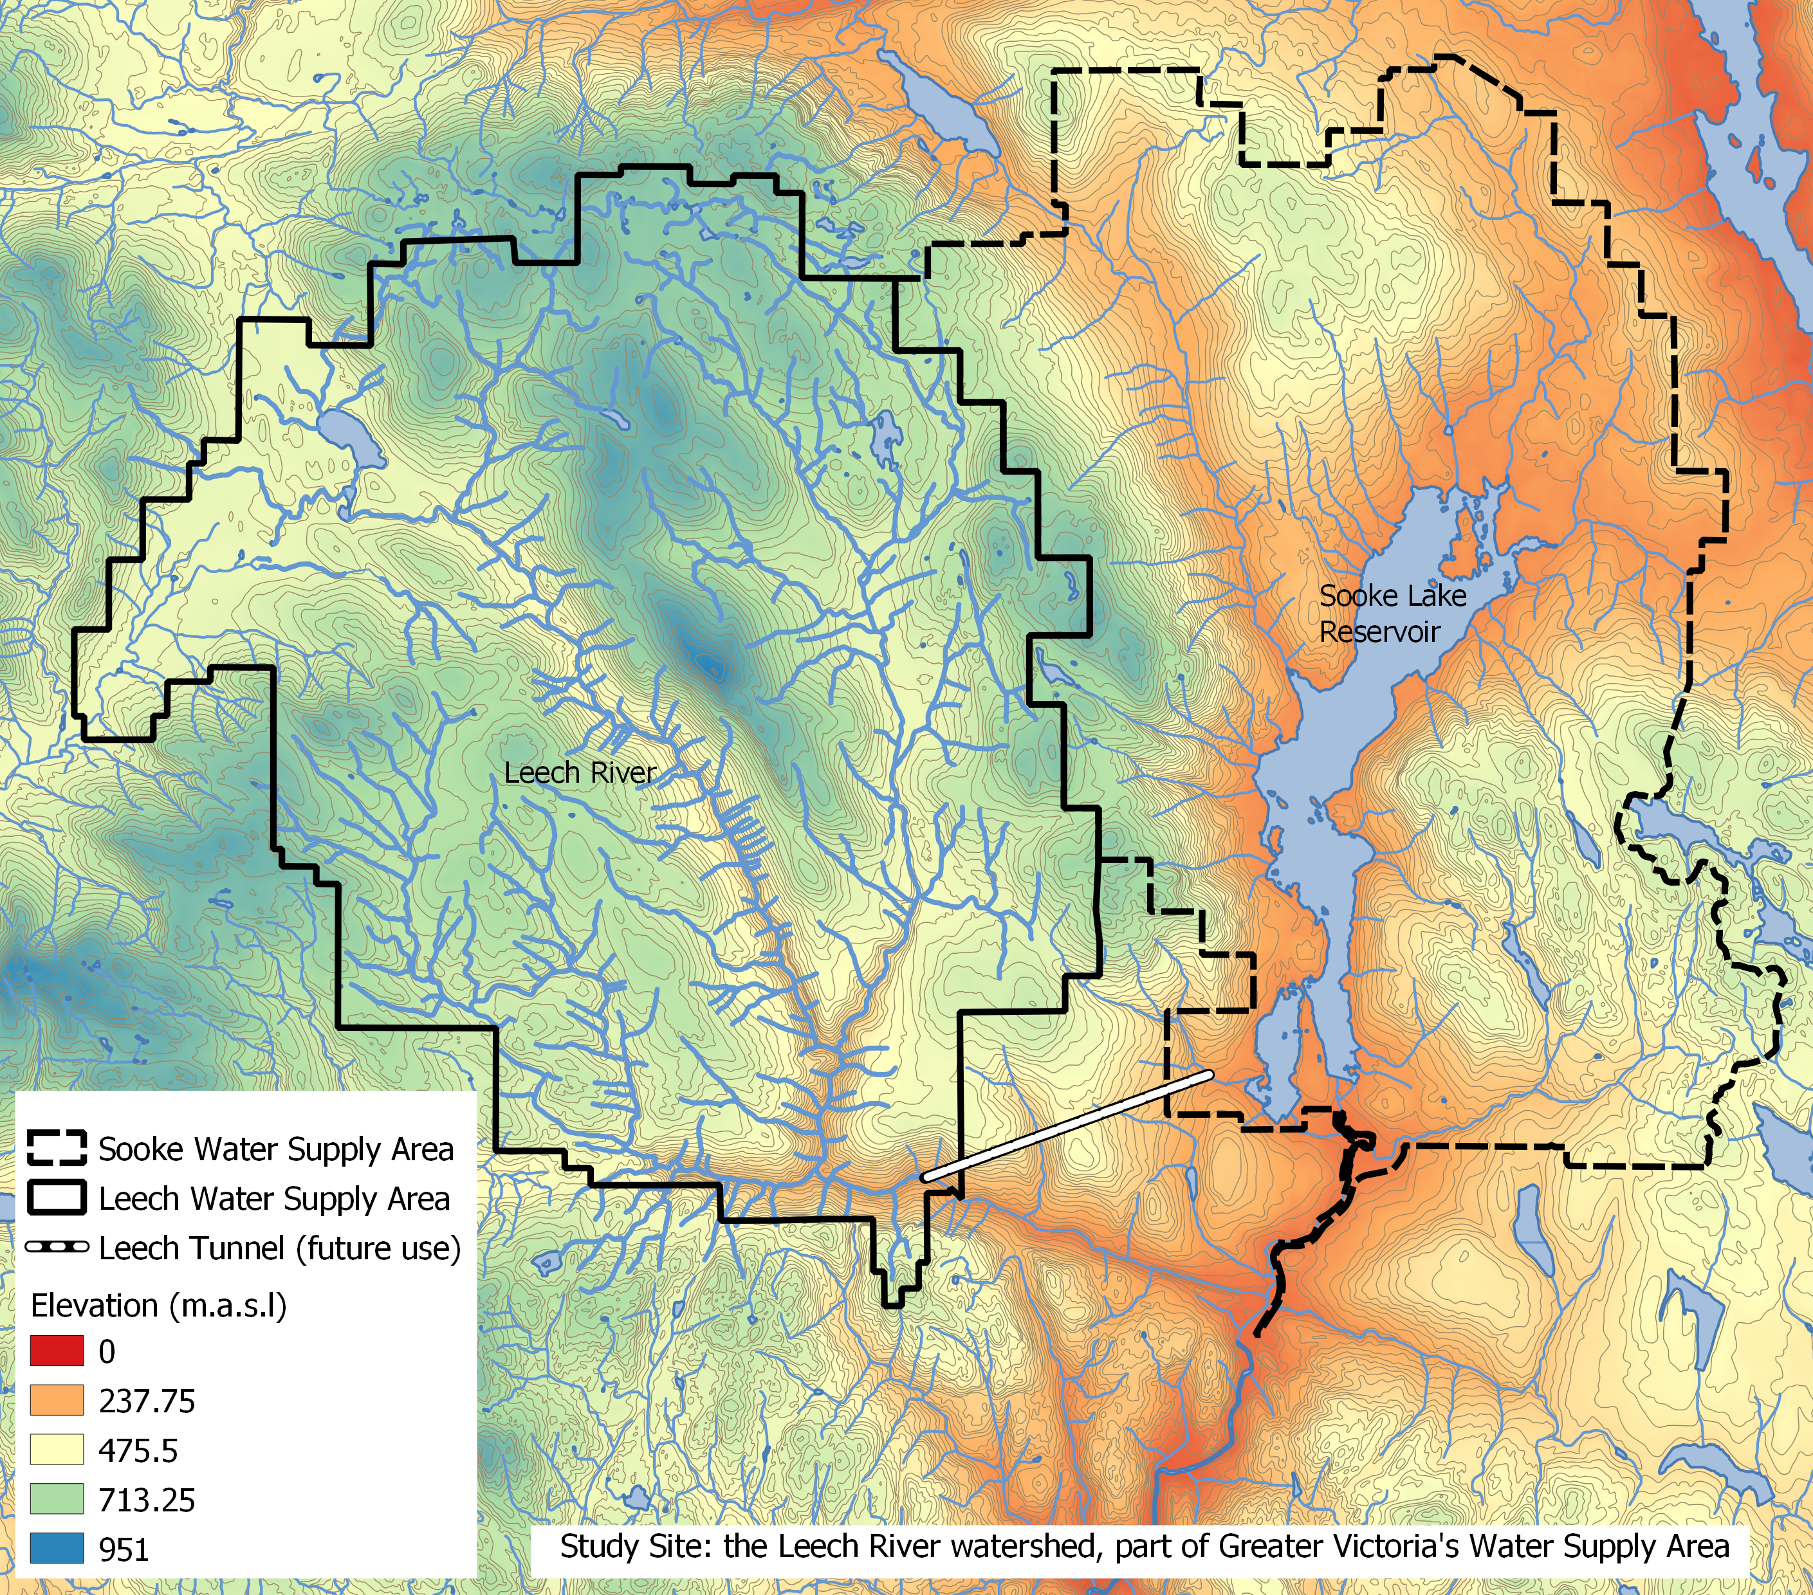

While monitoring programs began in 2017, the hydrology and water quality in the LWSA are poorly understood. The Leech River watershed includes three mainstem rivers (Cragg Creek, Leech River, and West Leech River) as well as several small headwater lakes (Weeks, Jarvis, and Worley) and wetlands (Jordan Meadows surrounding Weeks Lake and Lazar meadows north of Jarvis Lake). Runoff peaks in the winter under saturated conditions when rivers respond rapidly to precipitation events, rising and falling dramatically. Across the watershed, elevation ranges from approximately 200 m above sea level (asl), near the Leech Tunnel, to 941 m asl in the centre of the watershed, at the top of Survey Mountain.

### 2.1.1 Climate, Weather, Forests

The Leech River watershed is in the Coastal Western Hemlock biogeoclimatic zone (CWH), with forests dominated by Douglas-fir (Pseudotsuga menziesii), western hemlock (Tsuga heterophylla) and western red cedar (Thuja plicata); subspecies include white pine (Pinus monticola), amabalis fir (Abies amabilis), alder (Alnus rubra), broad-leaf maple (Acer macrophyllum) and arbutus (Arbutus menziesii). The watershed also includes the moist and dry maritime sub-zones of the CWH (Montane moist 43%, submontane moist 38%, xeric 19%) (Ussery and AECOM 2015). While some precipitation occurs as snow at higher elevations, the majority of the ~2500 mm per year is rain (i.e., pluvial hydroclimatic regime). The water year can be broadly divided into wet and dry seasons where approximately 90% of precipitation falls from October to April, and May through September are relatively dry.

There are two weather stations which operated during the study period: Chris Creek station is located in the headwaters of the LWSA and Martin’s Gulch station is located near the future diversion point (Tunnel). The CRD provided weather station data from Chris Creek and Martin’s Gulch weather stations from 2018-01-01 to 2020-01-30. Rainfall and air temperature from each of the two LWSA weather stations is shown in Figure ??. Slightly more precipitation was recorded at Martin’s Gulch than Chris Creek station. Between the two sites, average annual rainfalls were 2010 mm in 2018, and 1460 mm in 2019. In January 2020, the LWSA weather stations recorded 512 mm of rain (including periods of rain on snow).

These data included air temperature and precipitation. Precipitation data acquired from the CRD was used to delineate storms using (R package Rainmaker). Temperature data was referenced to subbasin temperatures recorded by vertical rack TidbiT loggers.

There is a weather station on the Malahat mountain pass, east of the study site (ID 62091, BC Ministry of Transportation and Infrastructure and Pacific Climate Impacts) that had precipitation and air temperature data available from 2014 to 2020.

### 2.1.2 Synoptic sampling sites

Fifteen sites were sampled synoptically from October 2018 to February 2020. Figure ### shows the locations of the synoptically sampled sites as well as the two weather stations. 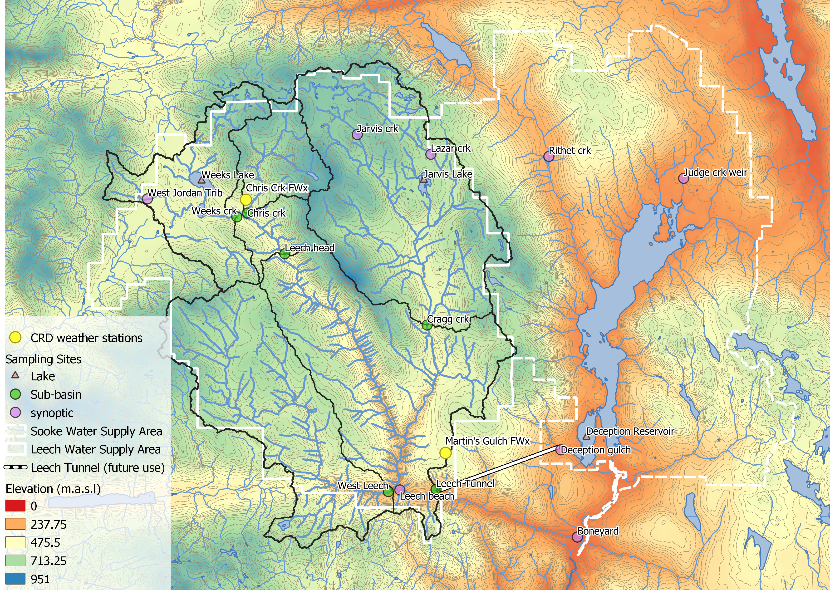

Synoptic sampling involved collecting grab samples in triple-rinsed acid-washed 250 mL amber HDPE bottles. Samples were capped with minimal headspace and transported on ice. Synoptic samples were collected bi-weekly to monthly. Results from synoptic sampling help to inform spatiotemporal patterns in water quality.

### 2.1.3 Subbasin monitoring sites

Six sites were selected across the Leech Water Supply Area which represent five nested catchments and the entire water supply area basin defined from the point of (future) diversion, the Leech Tunnel. These subbasin research sites represent important portions of the Leech River system: two headwater streams (Weeks and Chris Creek), the head of Leech River (below the confluence of the two headwaters), two mainstem rivers that feed the Leech (Cragg Creek and West Leech) and the Leech River at the Tunnel).



__Figure_*Subbasin monitoring sites in the Leech Water Supply Area*

#### 2.1.3.1 Subbasin sampling and installations

At each of the six subbasin research sites, a vertical sampling rack was installed. These racks collect discrete water samples during the rising limb of stormflow without employing costly pump-samplers, while recording continuous stage measurements (at ten minute intervals). Vertical sampling racks supplemented the synoptic sampling program by providing synchronized spatial resolution that would otherwise be difficult to achieve (i.e., multiple sites across the watershed), while collecting samples during flows that would otherwise be difficult or unsafe to access. Simultaneous stormflow sample collection can provide insights about relative hydrologic pulse responses across nested catchments (Abbott et al. 2018).

The passive sampling bottles employ principles of a siphon design to collect river water as it reaches pre-determined levels on a vertical sampling rack. Siphon sampler bottles were based on a USGS single stage sediment sampler design (US U-59, 1961) which passively collect discrete water samples at a fixed stage on the rising limb of the hydrograph (Graczyk et al. 2000). The siphon samplers built for this research were 250 mL amber HDPE widemouth bottles with augmented screw caps. The caps were fit with two 1/4" (OD) stainless steel tubes, one longer than the other, both with a 180 $​^{∘}$ bend at the top end.

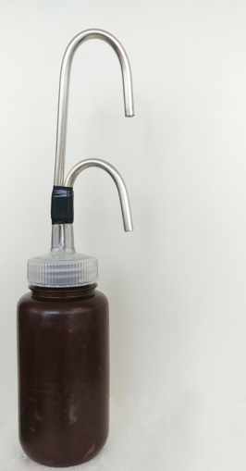

Each rack included a central stilling well (3.81cm (1.5“) PCV pipe with 1.27 cm (1/2”) holes along the length) with a measuring tape affixed to the front. Inside the stilling well was an [Odyssey Capacitance water level logger](http://odysseydatarecording.com/index.php?route=product/product&product_id=50); and on either side of the central stilling well was a slotted offset angle bar onto which hose clamps held sample bottles fit with custom siphon lids. By combining the height at which each siphon bottle filled with observed stage from the stilling-well tape and Logger data, the date and time for each rising-stage sample collection was determined.

These vertical racks collected whole water samples on the rising limb of the hydrograph. The rising limb has been shown to have higher DOC concentration than low flows between storm pulses (Yang et al. 2015; Raymond et al. 2016, 2010; Zarnetske et al. 2018). Increasing DOC on the rising limb indicates that source material is not limited and flux is driven by hydrologic connectivity; whereas source limited conditions likely drive DOM dynamics if DOC concentration decreases on the rising limb (Zarnetske et al. 2018). Analysis of rack samples clarifies the magnitude and direction of water quality changes in response to precipitation relative, which provides information about solute supply and hydrologic connectivity (Vidon, Wagner, and Soyeux 2008; Abbott et al. 2018; Creed et al. 2015; Zarnetske et al. 2018).

###### 2.1.3.1.1 Vertical rack sampling QA/QC: Siphon sampler assumptions

Rising level siphon samplers collect water from approximately 5cm below the surface (top of intake tube to inlet orifice). Data related to rack samples relies on two key assumptions: the water column is well mixed (no stratification) therefore the sample is representative of water quality at each sampling stage; and the sample is discrete such that there is no infiltration or mixing after the sample is collected. Based on the velocity and turbulence associated with flows in the step-pool formation of the subbasins, the assumption of unstratified waters seems very reasonable. The assumption of sample discretion was validated in lab using food colouring and a flow-through bucket system {tap water sample collected by siphon sample bottle, food colouring added to flow system after sample collection and circulated for ~15 minutes, sample bottle removed from dye chamber and sample colour compared to surrounding dyed water: no dye present in sample).

###### 2.1.3.1.2 Vertical rack sampling QA/QC: Sample hold-times and temperatures

Every effort was made to retrieve rack samples as quickly as possible from the racks, none the less they sometimes remained on the racks for several days (up to a week). Hobo TidbiT temperature sensors were deployed at each subbasin vertical rack to monitor air and water temperature in order to assess sample stability between sample collection and retrieval.

To assess sample stability hold-time experiments were performed. The hold-time experiments included replicate (n = 10) sample collection at a site, where half the samples were placed out of water on the vertical rack with siphon lids and the other half were returned to the lab for immediate analysis. Four hold-time experiments were completed such that the rack samples were left in the field for one, two, three, and four weeks before being retrieved and analyzed for comparison to their counterpart replicates.

###### 2.1.3.1.3 Prototype for falling limb passive sampling

In keeping with goals of low-cost, low-powered passive sampling, a falling-limb sampler was designed based on principles of the rising limb siphon sampler. The rising limb sampler collects a discrete water sample when river stage exceeds the crown of the inlet tube, so long as the vent is unobstructed; obstruction of the siphon sampler vent was the key component of the falling limb sampler prototype design. There were a half-dozen iterations in design prior to the model which was field-deployed in the Leech WSA (winter 2019). Each design iteration included a valve on the siphon vent which remained closed as the river rose, and opened when stream stage dropped below a certain point (allowing air to exit the sample bottle and a water sample to be collected). A number of valve options were explored, including: an external tube plug, in internal tube plug, and a self-sealing silicone bite-valve (i.e. Camelback Big BiteTM for hydration packs). The final design iteration used a tube pinch valve (SP Science) to close and open the air vent. The mechanism that triggers the vent valve to open is a simple fixed pulley, where the valve is connected to a weighted-cup by a wire that passes through two loops which alter the direction of force. The river rises and fills the cup with stream water, the cup remains full when the river recedes, and when the stream drops low enough that the full cup is no longer buoyant, the weight of water in the cup exerts a force on the lever of the pinch-valve, causing it to release the vent tube and triggering sample collection. The vent valve and trigger mechanism are contained in a 4" sewer pipe (a “filling well”), which was attached to supplemental support bars on the vertical rack. One prototype was field deployed at Cragg Creek (subbasin site 4) as a proof of concept and work will continue to improve the design and operation.

### 2.1.4 forWater Coordinated Treatability Analyses Sites

Four of the synoptic sampling sites were selected to collect source water treatability data in collaboration with researchers in the forWater Network. The sites were:

1. the Leech River at the future point of diversion,   
2. Deception Reservoir  
3. Rithet Creek (2nd largest tributary to Sooke Reservoir)   
4. Judge Creek (largest tributary to Sooke Reservoir)

These sites were selected to represent the future supplemental source water, the terminus or future balancing reservoir between Leech and Sooke water supply areas, and the current tributary source waters in the Sooke WSA (respectively).

Replicate samples were collected November 12, 2019 and January 18, 2020 and were shipped to the Universities of Alberta and Waterloo for treatability analyses. At the University of Waterloo, samples were analyzed for treatability parameters including: maximum potential disinfection byproduct formation potential (for trihalomethanes and haloacetic acids, (μg/L)), pH, UV254(cm-1), DOC (mg/L), Turbidity (NTU), Zeta Potential (mV), THM-FP(μg/L), HAA-FP (μg/L). At the University of Alberta, field-filtered samples were analyzed using a spectrofluorometer (for excitation emission matrices spectra), as well as an fourier transform ion cyclotron resonance mass spectrometer to determine molecular characteristics of the DOM.

## 2.2 Analytical techniques & data

Water samples were collected and transported via coolers (on ice) to UBC’s EcoHydrology Lab for analysis of dissolved organic carbon (DOC) concentrations and indicators of NOM character. Samples were also measured for phosphate concentration using a colourmetric (ascorbic acid) orthophosphate test kit (HACH PO-19); each sample had phosphate concentrations below detectable limits (0.1 mg/L). All data were analyzed with R (3.6.2) using RStudio IDE (Version 1.3.820).

### 2.2.1 Quantifying dissolved organic carbon (DOC, as NPOC)

For quantification of DOC, samples were analyzed for non-purgeable organic carbon (NPOC) via High-Temperature Combustion (Method 5310-B) on a Shimadzu TOC-V (Eaton, A. D., Clesceri, L. S., Greenberg, A. E., Franson 2000). For this method, samples were filtered with 0.45-micron PES filters, acidified to bring pH below 2, then sparged with hydrocarbon-free air to drive off inorganic carbon. Following sparging, samples were combusted to convert all organic carbon to carbon dioxide which was measured by non-dispersive infrared gas detector to quantify the DOC content of the sample. This method represents a direct measure of DOC; although small volatile organic compounds would be removed in the sparging process, most NOM compounds are of higher molecular weight and it is unlikely that NOM analytes would be lost (Eaton, A. D., Clesceri, L. S., Greenberg, A. E., Franson 2000; Matilainen et al. 2011).

### 2.2.2 Qualifying organic matter through spectrophotometry

#### 2.2.2.1 Proxy DOC

Spectral properties of sample NOM were analyzed using a ‘spectro::lyser’ spectrophotometer (s::can, Vienna, Austria) which measures turbidity and the chromophoric portion of organic matter to estimate concentrations of total organic carbon (TOC), dissolved organic carbon (DOC), as well as nitrate-nitrogen (NO3--N). For NOM to be detected by UV-Vis absorption, the molecules must absorb ultraviolet (UV) or visible (Vis) light, which relies on the electronic structure of the molecules. UV-Vis absorption requires the presence of conjugated pi-bond systems (i.e., chromophore) in the molecule, which are common in aromatic systems. Therefore, DOC quantified by the spectro::lyser is a proxy measure that represents the chromophoric component of DOM (CDOM), which is proportional to the samples’ average aromaticity. The suite of molecules that comprise NOM generally have an aromatic character (Weishaar et al. 2003). Increasing aromaticity will lead to greater absorbance at longer wavelengths, therefore an absorbance spectrum can provide information about a samples molecular character. For example, absorption of near-UV wavelengths (i.e., 200-380 nm) is indicative of conjugated systems that are common to aromatic compounds; as such, specific UV absorbance at 254nm (SUVA254) has been adopted as a surrogate for DOM aromaticity and, to some extent, its reactivity (Weishaar et al. 2003; Chow et al. 2008). The spectro::lyser measures absorbance from 200 nm to 750 nm wavelengths, across which several spectral indicies can be calculated.

#### 2.2.2.1.1 Quality control note

The spectro::lyser has been shown to effectively determine DOC content and character on unfiltered samples (Avagyan, Runkle, and Kutzbach 2014). However, suspended matter may bias absorbance values due to non-DOC light absorption or scattering. Therefore, spectral indices were not calculated for several unfiltered water samples that had detectable turbidity (greater than 0.000 FTU); this reduced the spectral dataset by 9.5%, from 347 to 314 spectral samples.

#### 2.2.2.2 SUVA254

Specific ultraviolet absorbance at 254nm (SUVA254) is the ratio of UV absorption (spectral absorbance coefficient, SAC, m-1) at 254nm wavelength, normalized to DOC concentration (mgL-1) (i.e., SAC254 divided by mgL-1-DOC) (Weishaar et al. 2003). SUVA254 correlates strongly with DOM aromaticity, and loosely with reactivity (Weishaar et al. 2003; Helms et al. 2008; Chow et al. 2008). A higher SUVA value indicates greater aromaticity, and a lower SUVA value indicates more alliphatic DOM. Because humic substances are more aromatic, SUVA254 is a good indicator of DOM from humic sources (i.e., allochthonous NOM) (Weishaar et al. 2003; Vidon, Wagner, and Soyeux 2008; Abbott et al. 2018).

With respect to SUVA254 and drinking water treatability, it’s important to consider the diversity of DOM and DBP species and the heterogeneous character contained in a water sample. While SUVA254 may indicate reactivity, it is not necessarily a strong indicator of DBP-FPs (Weishaar et al. 2003; Chow et al. 2008). This is because some DBP precursor NOM components (e.g., alliphatics), which have negligible absorptivities in the UV-Vis range, may contribute to DBPs but not SUVA254; additionally, not all NOM with measurable SUVA254 will create DBPs (Weishaar et al. 2003).

SUVA254 is reported in units of liter per milligram carbon per meter (Lmg-C-1m-1) and was determined by dividing the UV absorbance measured at wavelength 254 nm by the DOC concentration (from NPOC on the Shimadzu TOC-V).

#### 2.2.2.3 spectral indices of NOM character

Based on full scan data from the Spectrolyser (250-700nm), several indices of NOM character were determined. In the absence of fluorescence excitation-emission matrices, or high resolution spectrometric methods, spectral slopes are a simple tool for getting at molecule character. Spectral slopes (i.e., the change in absorbance intensity over a range of wavelengths) are semi-quantitative indicators for assessing DOM molecular weights (Helms et al. 2008). Spectral slopes over the wavelength range of 275-295 nm (S275-295, likely range for absorption by poly-aromatic hydrocarbons with 2 or more rings) and 350-400 nm (S350-400) were calculated from linear regression of loge-transformed spectra (spectral absorbance coefficients, m-1) as indicated by Helms (2008, p 958). Slope ratio (SR) is a unitless value equal to the slope of spectral intensity over the wavelength range of 275-295 nm relative to the slope of spectral intensity over 350-400 nm. SR is inversely proportional to CDOM molecular weight (Helms et al. 2008).  
The ratio of absorbances at wavelengths 250 nm and 365 nm provides a quotient called E2:E3 which is inversely related to aromaticity and molecular size of aquatic humic solutes (**???**; Helms et al. 2008). E2:E3 values were calculated, along with SR , to try to elucidate molecular character of DOM in samples.

### 2.2.3 Sampling for Metals & CRD Analytical Results

Aquatic NOM can play an important role in the transport of metals because it has the physiochemical ability to act as a ligand to create coordinated complexes with metals. From November 2018 to July 2019, I collected eight sets of samples for metals analysis from the six sub-basin monitoring sites. Metals samples were collected on behalf of the CRD and were analyzed at Bureau Veritas Laboratories in Sidney, BC (BL Labs, formerly Maxxam Analytics Inc.). For each metals sample collected, a parallel Grab sample was analyzed for DOC (at UBC). Reports from BL Labs were provided by the CRD for the samples collected in association with this research. Reports were pdf format which was exported to Excel and converted to .csv for analysis in R.

# Data & Results (visualization & summaries)

# Discussion

Here is a research chapter. Look a graph in Figure ??.

Also check out the associated data in Table ??.

# Conclusions

I did several things and will now discuss why they are good.

# References

# Appendix A

## A-1 Greater Victoria Regional Water Supply System

The Capital Regional District (CRD) owns and operates the water supply system for the Greater Victoria region. As a water purveyor, CRD supplies an average of 130 million liters of treated water to customers each day (130,000 m3day-1) (CRD 2017). The provision of safe and sustainable drinking water has three tiers of regulation above the CRD: federal, provincial, and regional. Federally, Health Canada publishes Canadian Drinking Water Quality Guidelines which outline quantitative bounds for microbial, chemical, radiological parameters and physical aesthetic characteristics for safe drinking water. The province of British Columbia sets requirements for planning, reporting and regualting of drinking water providers through the Drinking Water Protection Act and the Water Sustainability Act, and the Public Health Act and Regulations. Regionally, the CRD reports to the Vancouver Island Health Authority (Island Health) regarding water quality information and provincial legislation.

The Greater Victoria Water Supply Area (GVWSA) includes 20,549 hectares (205.49 km2) of protected drinking water catchment lands. The primary water supply is sourced from Sooke reservoir, the secondary supply source is Goldstream reservoir and the designated (supplemental) future water supply is the Leech River watershed {FIGURE YYY, figure of watersheds with insert of VanIsle (small) and western north america (even smaller)}. Unfiltered source water is first treated with ultraviolet light and free chlorine (to deactive parasites, bacteria and viruses); secondarily, ammonia is added to produce chloramine, a long-lasting disinfectant that persists through distribution systems (CRD 2017).

The Leech River watershed is a sub-catchment of the Sooke River watershed (~25% by area), located west of Sooke Reservoir (primary water supply for the Greater Victoria Area). In anticipation of future water demands and uncertainty related to rainfall and climate change, the Capital Regional District (CRD) purchased 9,628 hectares (about 92%) of the Leech River watershed in 2007 (84%) and 2010 (additional 8%), and designated the Leech Water Supply Area (LWSA) for future supplemental water supply.

In 1977, the CRD obtained a provincial water licence authorizing the diversion of up to 30.6 million cubic meters per year from the Leech River to the Sooke Reservoir (Ussery and AECOM 2015). Based on the 2017 strategic plan statement of a daily average water supply of 130,000 m3 (2017), the Leech water license could contribute about 65% of 2017 average water supply. The license allows diversion only as long as minimum flows (>5.7 m3s-1) are maintained to protect fish and downstream ecology (Ussery and AECOM 2015). Based on current hydroclimatic dynamics, the water license flow requirements will exclude the summer months from inter-basin transfer and limit streamflow diversion to the winter (November to approximately April). The Leech Tunnel was constructed in the 1980’s to transfer Leech River water into the Sooke Reservoir. The Tunnel is not currently operational, and it’s anticipated that inter-basin transfer won’t be required until 2050 or later.

To prepare for the eventual use of the LWSA, further work is required to plan for the water quality impacts of the different raw water sources, rehabilitation of the water supply area forests and drainage structures, and infrastructure necessary to convey the LWSA flows into Sooke Lake Reservoir ~(CRD 2017)

## A-2 Leech River Watershed Site Details

The Leech River watershed (“the Leech”) is located on south-east Vancouver Island, British Columbia, Canada. Like most of coastal BC, it is in the Coastal Western Hemlock Biogeoclimatic Zone. The hydroclimatic regime of the Leech is pluvial (i.e. rain-dominated). Annual rainfall is typically between xxxx - yyyy mm (~2500 mm/yr). This areas has a strong seasonal distribution of rainfall: approximately 90% of rain falls from September to April, with only about 10% of annual rainfall occurring from May to August [*REFS*]. Across the Leech, elevation ranges from approximately 200 m above sea level (asl), near the Leech Tunnel, to 941 m asl in the centre of the watershed, at the top of Survey Mountain. While the majority of precipitaiton falls as rain, snow does accumulate for short periods at higher elevations.

Around 99% of the Leech WSA is forested. The Leech forests are dominated by western red cedar, western hemlock, and Douglas fir; subspecies include Amabalis fir (Pacific silver fir), white pine, yellow cedar (at higher elevations), Alder, broadleaf maple, and arbutus. Prior to purchase by the CRD, the LWSA was privately managed forest land that was harvested from the mid-1940’s to 2007 (Ussery and AECOM 2015). Approximately 95% of the Leech watershed was harvested by clear cut prior to 2007 (Ussery and AECOM 2015, @CRD2019); as a result, ~94% of LWSA forests are younger than 60 years old and a large portion of stands are under 30 years of age. Now designated as a Water Supply Area, the CRD manages the Leech for source water protection, ecosystem services, and forest resilience. As forest fires pose a serious threat to monocultured and even-aged stands (*REFS*), particularly during the drought of summer, forest fuel management is an important preemptive risk reduction for the CRD (CRD 2019).

The Leech River system is composed of three mainstem rivers, numerous tributaries, and four small headwater lakes. Hydrologic responses vary with terrain steepness, soil infiltrability, vegetation, percent cover of lakes and wetlands, air temperature and the intensity and duration of precipitation. In the Leech, runoff peaks in the winter under saturated conditions. In the wet season, rivers in the Leech watershed are flashy: they respond rapidly to precipitation events, rising and falling dramatically. In 1993 CRD Water Services set up a hydrometric monitoring station on the Leech River (about 3.5 km downstream of the Tunnel) to measure discharge with hourly stage measurments (Ussery and AECOM 2015). Peak flow on the lower Leech River was recorded as 168 m3s-1 (in October, 2003) (Ussery and AECOM 2015). However, the rating curve at this historic gauging station was not verified over time and hydraulic action rendered it fairly unreliable.

Overall, the hydrology of the LWSA is poorly understood, as are water quality dynamics. In the mid-1980’s, some water was transfered from the Leech River into Deception Gulch and Reservoir (adjacent to but physically separated from Sooke Reservoir). The mixing resulted in biological water quality problems that included odour and raised concerns about the operational usage of the existing tunnel. The Leech River Tunnel and anticipated inter-basin transfer will provide interesting research opportunities which are beyond the scope of this thesis research. Before work is done on inter-basin transfers, the hydrology and water quality of the Leech River system need to be better understood. Understanding source water quality, as well as the timing and magnitude of flows, is an essential component to multiple barrier approach to ensuring clean drinking water.

### A-2.1 Sub-basin Sites

Six sites were selected across the Leech Water Supply Area. The six research sites represent five nested catchments and the entire water supply area basin defined from the point of (future) diversion, the Leech Tunnel.

#### A-2.1.1 Weeks Outlet

The Weeks Outlet research site monitors water draining approximately 16 km2 of the northwest Leech River watershed, including a wetland (Jordan Meadows fen) and Weeks Lake (approximately 27 ha) (Ussery and AECOM 2015). Jordan Meadows wetland drains to the east and joins the outflow of Weeks Lake (south end of the lake). The wetland and lake outflow streams join and flow east to Research Site #1, “Weeks Outlet”, which is a third order stream (Strahler) of the western headwaters of Leech River. The channel is fairly straight and bed material is primarily silt/clay. The water at this site was noteabley tannin-coloured. This research site was located about 0.4 km west (upstream) of the confluence with Chris Creek.

A large culvert upstream of the monitoring site was replace with a bridge in August of 2019. The culvert had been perched above the streambed level and was obstructing the movement of fish and water flow. Prior to the culvert removal, several groundwater seeps were observed downstream; these seeps maintained base flow of summer waters in this low-relief stream reach. There were high levels of iron (above guidlines for aesthetic objectives) in the water downstream of the culvert, possibly due to culvert rust.

![](R-inputs_UBC-forWater-MSc_HMc/images/XXXXX.jpg){width=50%} ![](R-inputs_UBC-forWater-MSc_HMc/images/YYYY.jpg){width=50%}

#### A-2.1.1.2 Chris Creek

Chris Creek is the western headwaters of Leech River. This research site is approximately 0.2 km east (upstream) of the confluence with the Weeks Outlet stream. The study site on Chris Creek monitors waters draining from approximately 9.6 km2 of forested land, including Worley Lake (approximately 3.5 ha) (Ussery and AECOM 2015). The monitoring site of Chris Creek was downstream of a bridge, on a slightly sinuous reach with boulders and bedrock dominated morphology and turbulent cascading step-pools. There is a brige that passes over Chris Creek and a large collection of coarse woody debris downstream of the bridge, upstream of the monitoring site.

![](R-inputs_UBC-forWater-MSc_HMc/images/XXXXX.jpg){width=50%} ![](R-inputs_UBC-forWater-MSc_HMc/images/YYYY.jpg){width=50%}

#### A-2.1.1.3 Leech Head

Research site 3 was approxiamtely 1.4 km downstream of the confluence of Weeks Outlet stream and Chris Creek. The “Leech Head” study site was in a deep pool between riffles, it’s a 4th order stream with predominantly Schist bedrock and fairly low relief (~2%) and relatively straight morphology. The water at this site was often coloured by tannins (likely from the Weeks outlet stream contributions). There once was a logging bridge across the river at this site, and some rip-rap remains on either bank.

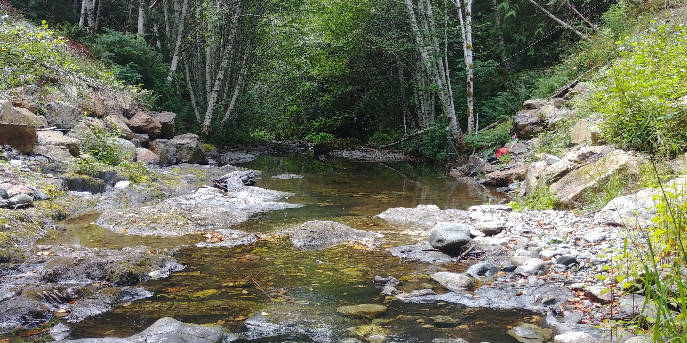

#### A-2.1.1.4 Cragg Creek

Cragg Creek is a mainstem river that originates in the northeast of the Leech River watershed. Cragg Creek is a 4th order stream and this research site location has a drainage area of approximately 37 km2, which includes Jarvis Lake (15 ha). The Cragg Creek research station was installed upstream of a road bridge, at a CRD hydrological monitoring site (installed over the span of this thesis project). The bed morphology at this site is Schist bedrock and the stream is straight channel with fairly high width-to-depth ratio. Upstream of the bridge Cragg Creek flows turbulently along a low slope, and downstream of the bridge it cascades into several deep pools. From the Cragg Creek research site, the river flows approximately 4.5 km through a steep revine to confluence with the Leech River (this confluence is around 6 km downstream of the Leech Head site, site #3).

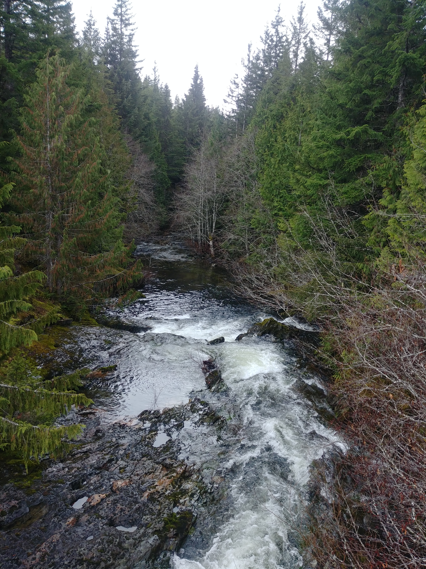

Cragg Creek downstream(left) and upstream (right) of bridge

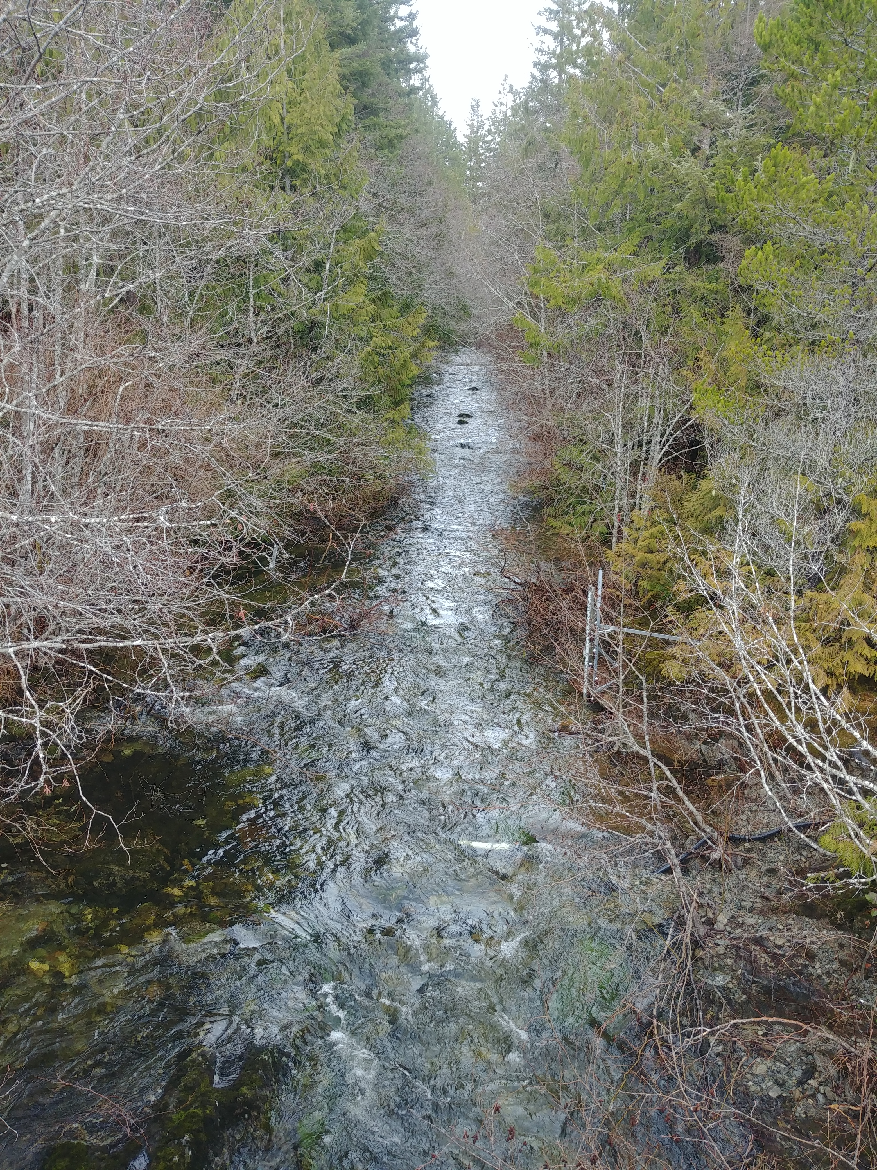

#### A-2.1.1.5 West Leech

Originating in the west of the Leech River watershed, West Leech River is a 4th order mainstem river. The West Leech research site monitors a drainage area of approximately 35 km2 which includes a small lake (Boulder lake) at the southwest of Leech watershed. This reasearch site has boulder and bedrock substrate, fairly straight channel with relatively high width-to-depth ratio and pool-riffle morphology. The West Leech site is approxiamtely 120m upstream of the confluence with Leech mainstem (~1.5km downstream of the confluence of Cragg Creek with Leech River).

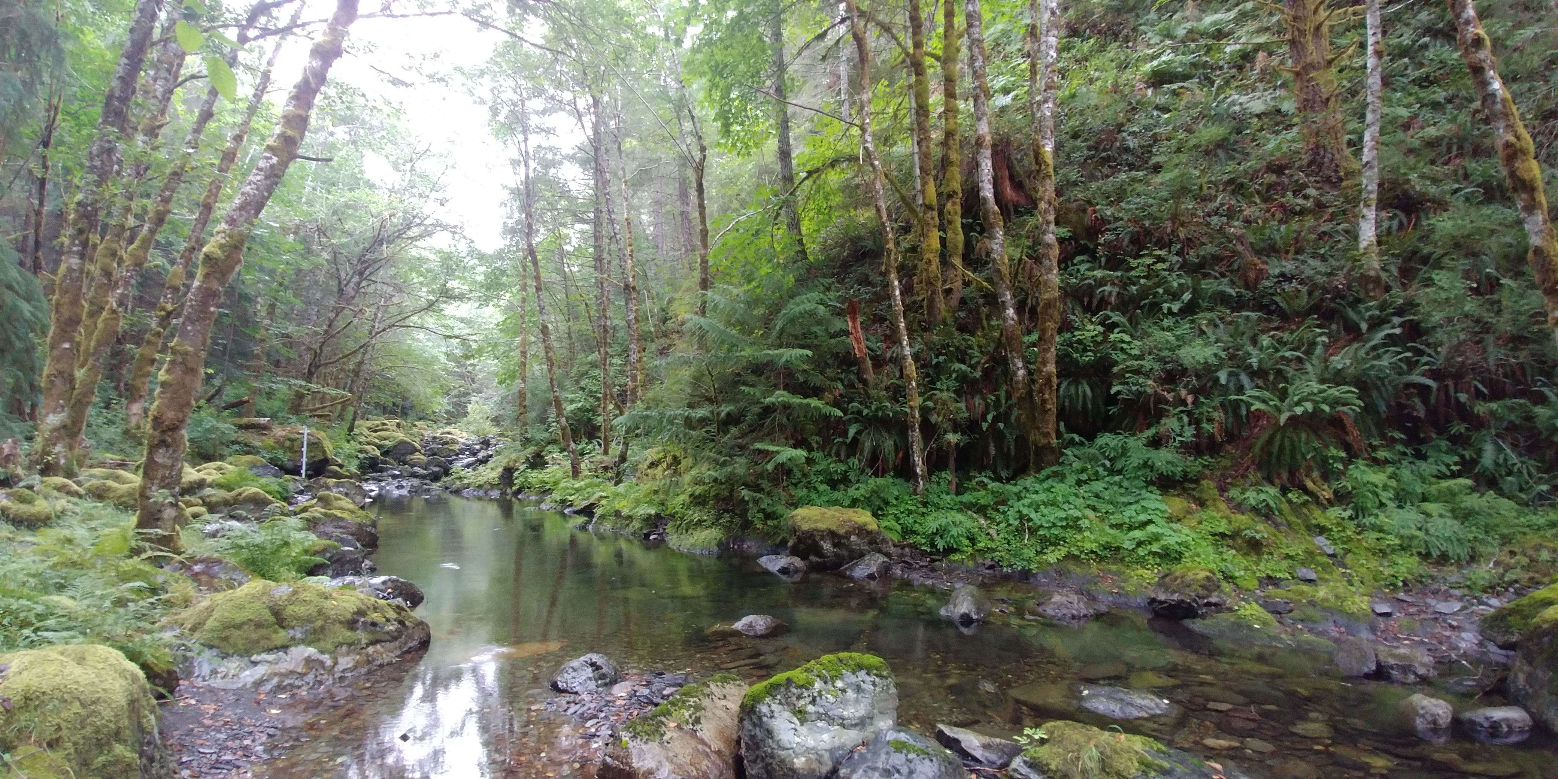

West Leech lowflow (left)

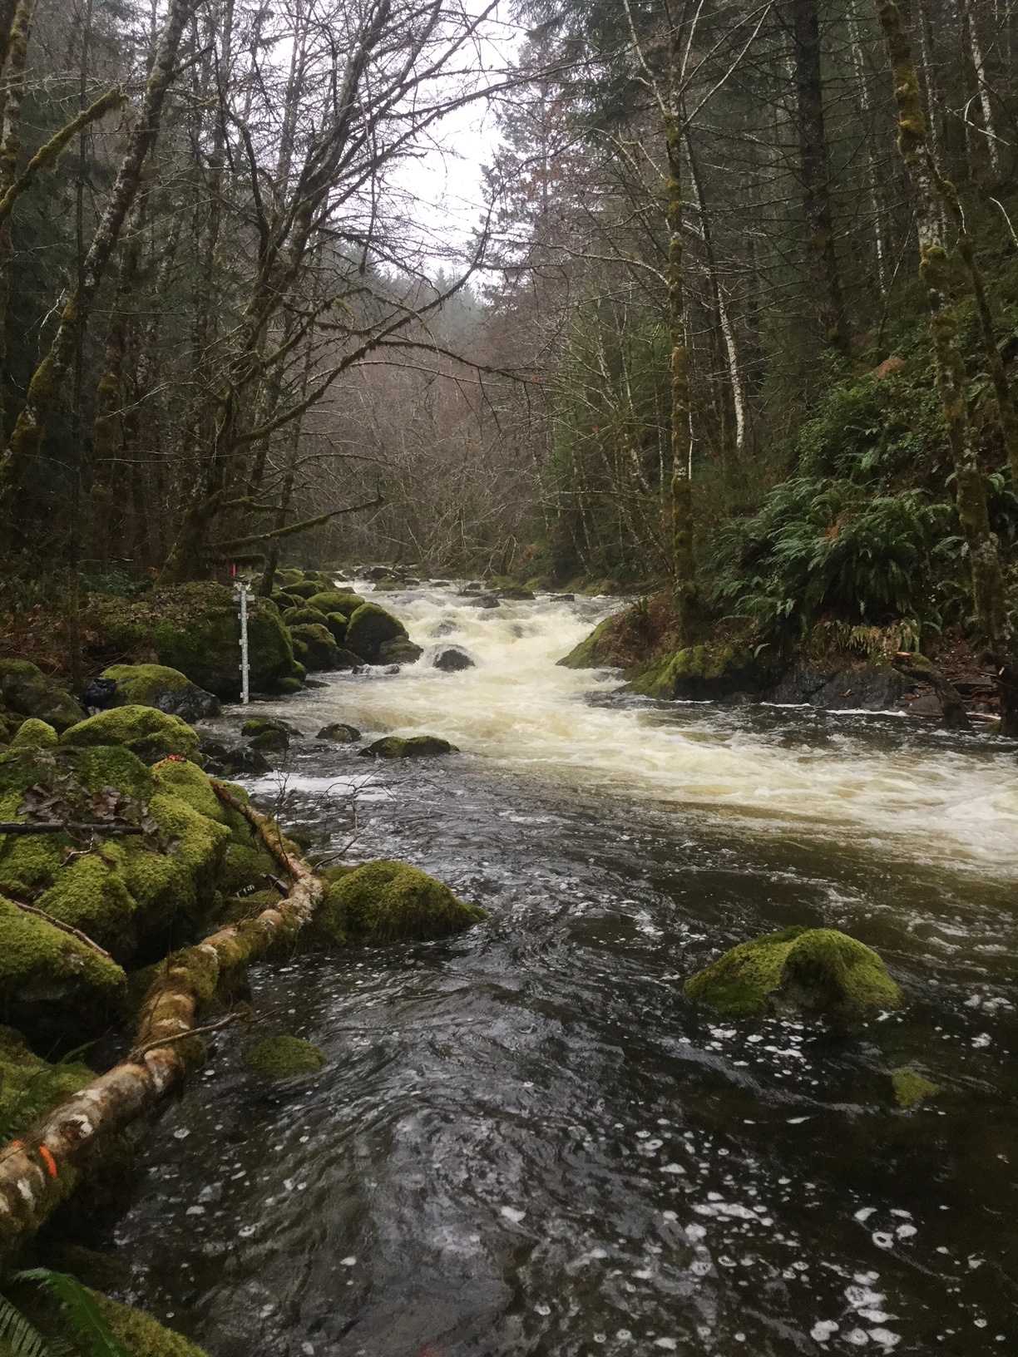

West Leech high flow (right)

#### A-2.1.1.6 Leech Tunnel

This research site is at the point of future diversion, the Leech Tunnel. The Leech River is 5th order, and this research site has a drainage area of approximately 99 km2. The streambed here is dominated by Schist bedrock and boulders. The bedrock in the center of the channel is deeply incised, but overall the river is wider than is is deep. The Tunnel site is approximately 1km downstream of the West Leech confluence.

![](R-inputs_UBC-forWater-MSc_HMc/images/XXXXXXX.jpg){width=25%, style="float:left; padding:10px"}

## A-3 Methods (extended)

In riverine systems, peak flows are critical times for mass transport of dissolved and suspended materials. Therefore water quality sampling should include proportional representation of stormflow pulses relative to between-storm flows and baseflow. Sampling programs can range from low-cost synoptic grab sampling campaigns to high-cost programmable pump samplers (e.g. ISCO). Synoptic grab sampling was completed across the six primary Leech research sites, as well as four supplemental sites. In addition to synoptic sampling, passive sampling techniques were employed to collect stormflow samples.

Siphon sampler background – separate from vertical rack? Mark’s suggestion

### A-3.1 Vertical racks: passive water sampling on the rising limb of hydrograph

Each vertical rack included a central stilling well (1.5" PCV pipe (conduit) with 1/2" holes drilled along the length) that had a measuring tape affixed to the front. Inside the stilling well was an [Odyssey Capacitance water level logger](http://odysseydatarecording.com/index.php?route=product/product&product_id=50). To either side of the central stilling well, slotted offset angle bars were fixed and siphon sampler bottles were attached to the slotted angle bars with hose clamps.

The siphon sampler bottles were based on a USGS single stage sediment sampler design (US U-59, 1961) which passively collect discrete water samples at a fixed stage on the rising limb of the hydrograph. The siphon samplers built for this research were 250 mL amber HDPE widemouth bottles with augmented screw caps. The caps were fit with two 1/4" (OD) stainless steel tubes, one longer than the other, both with a 180 $​^{∘}$ bend at the top end.



**Figure 4**: Rising limb siphon sampler bottle

The lower tube acts as an inlet that intakes water once the stream level is at or above the crown of the bend, while the taller tube acts as a vent to allow air to exit the sample bottle as it is displaced with water. Once the sample bottle is full, there is no exchange with the surrounding stream water due to an air lock created in the vent tube bend. The validity of assuming sample collection is discrete is addressed in the *Methods QA/QC* section (following).

Sampling bottles could be placed at any height, and were generally staggered at 10-20 cm intervals. For each sampler bottle, the height of the intake tube (filling stage) was measured relative to the measuring tape on the central stilling well, which was referenced to the stage recored by water level logger inside to extract the date and time of sample collection (REF TO R SCRIPT).

#### A-3.1.3 Benefits, challenges and assumptions

The benefits of using these vertical racks as a method of sampling include: low cost (about $500 CND per installation), low power (two 1/2-AA batteries in each logger), self-contained (no external power source or data logger required), customizable design, passive sampling (no pumps). The downsides of using this technique are similar to any autosampler, in that someone must visit the field sites regularly for set-up and collection of samples, but because there are minimal powered components, mis-firing is not an issue. The only reason a sample wouldn’t be collected was if the stream stage did not reach a bottles intake. The primary drawback of this technique is that sampling is limitied to the rising limb of the hydrograph, which limits the elucidation of stormflow water quality dynamics. There is some uncertainty about timing between sample collection and sample retrieval, every effort was made to return to each research site following precipitation events to retrieve collected samples, and it was assummed that any sample held on the rack was stable due to low air and river temperatures during the wet season. The assumption of river-as-a-refrigerator was addressed by deploying temperature sensors on each vertical rack (August 2019), and also with hold-time experiments (discussed in *Methods QA?QC* section below).

#### A-3.1.4 Field protocol

Following the installation of a vertical sampling rack, the field protocol was to visit the site approximately biweekly (or more frequently, based on storms) to check, collect and set the rack. Every time a site was visited, a grab sample was also collected. When a bottle was placed on its rack (attached by 3" hose clamp), the filling stage (height of intake tube crown) was recorded relative to the central still well tape. Bottles were staggered, generally from water level to approximately 120 cm above water level (as experience showed that a bottle should always be placed above the stage of anticipated peak streamflow). Following a rain event, each site was revisited to collect rack samples; for full bottles, the siphon lid was replaced with a labelled HDPE lid and samples were transported in a cooler with ice packs back to the lab and refrigerated until analysis.

#### A-3.1.5 Method QA/QC: rising limb sampler quality assurance and quality control

The methods of passive sampling by vertical racks involve a couple of potential quality control challenges and assumptions. The two key challenges with these methods are the assumption of discrete sample collection, and sample stability during the elapsed time between collection and analysis. These issues were addressed experimentally and are discussed here.

#### A-3.2 Development of a modified siphon sampler designed for passive water collection on the falling limb of hydrograph

##### A-3.2.1 Theory

##### A-3.2.2 Design

##### A-3.2.3 Benefits, challenges and assumptions

##### A-3.4 Gauging Streamflow (? not yet completed)

##### A-3.5 QA/QC Laboratory Analysis

###### A-3.5.1 Instrument calibration

###### A-3.5.2 Calibration verification (cal vers)

## A-4 Details: forWater NSERC Strategic Network for forested drinking water source protection technologies

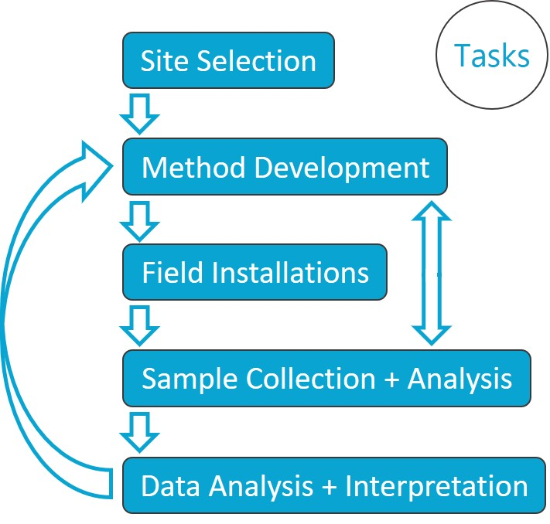

**Figure 2:** *Masters thesis task flowchart*

The forWater Network is a transdisciplinary cross-Canada applied research collaboration focused on the connections between treated drinking water quality and land-use impacts of forest management. The majority of source drinking water originates in forested headwaters, but the connection between upstream forest management and downstream treatment remains poorly understood. Across Canada, forWater researchers are studying water quality in watersheds under a variety of different forest management strategies. Through collaborative analyses, forWater is working to evaluate source water treatability metrics, downstream propagation effects, and resource economic with the ultimate goal of providing a framework for treatement demands as they relate to forest management strategies.

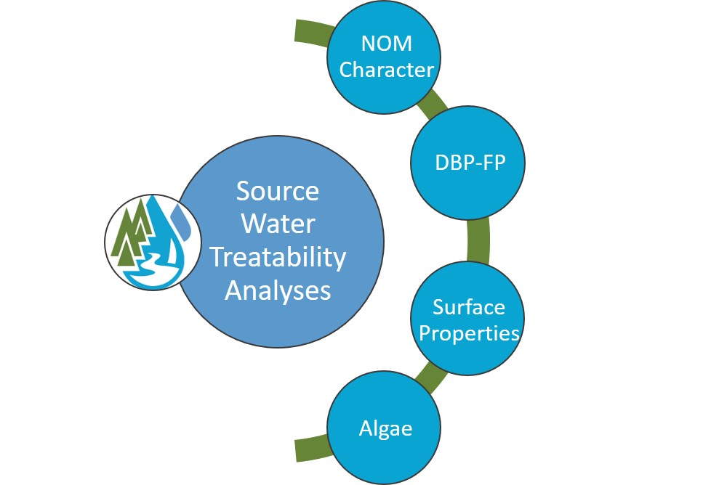

forWater NSERC Network for Forested Drinking Water Source Protection Technologies

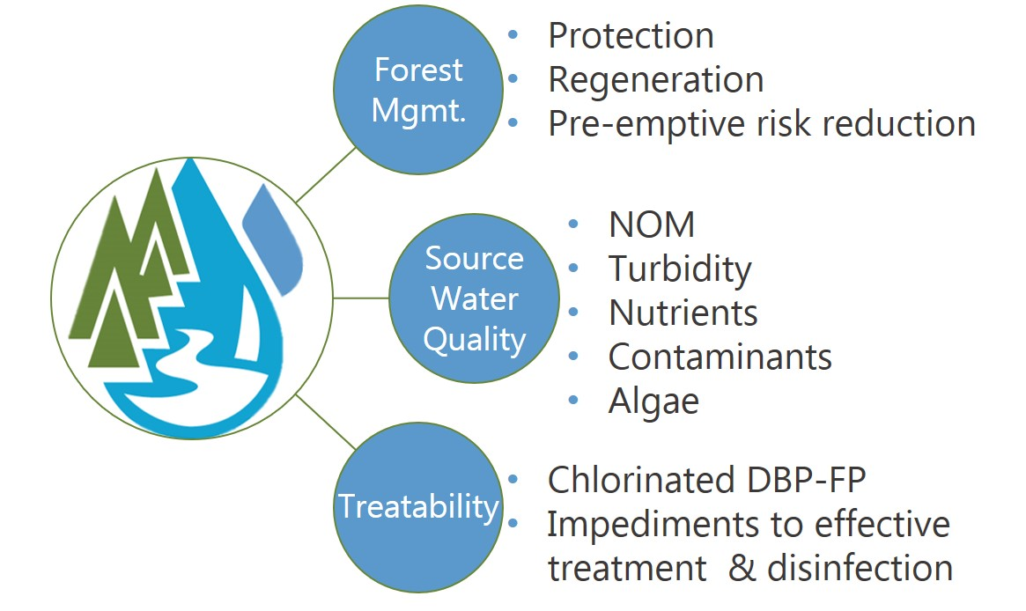

forWater NSERC Network for Forested Drinking Water Source Protection Technologies

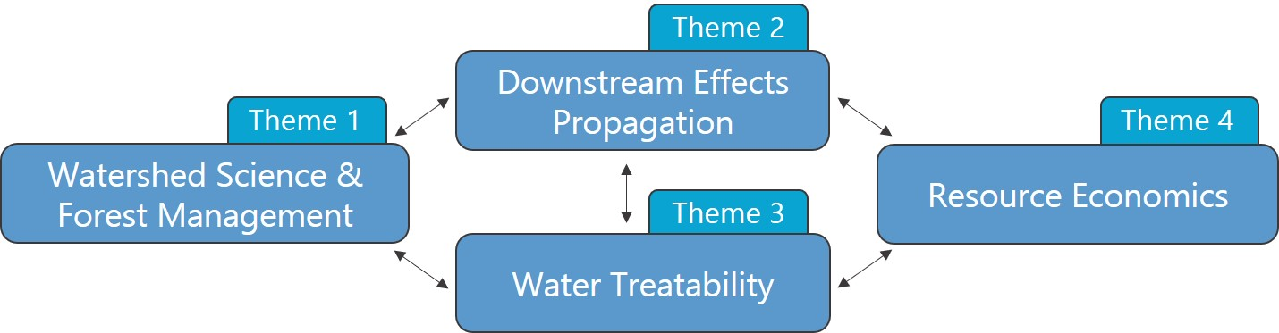

forWater Research Themes

# References

Abbott, Benjamin W., Gérard Gruau, Jay P. Zarnetske, Florentina Moatar, Lou Barbe, Zahra Thomas, Ophélie Fovet, et al. 2018. “Unexpected spatial stability of water chemistry in headwater stream networks.” *Ecology Letters* 21 (2): 296–308. <https://doi.org/10.1111/ele.12897>.

Aiken, George R., Heileen Hsu-Kim, and Joseph N. Ryan. 2011. “Influence of dissolved organic matter on the environmental fate of metals, nanoparticles, and colloids.” *Environmental Science and Technology* 45 (8): 3196–3201. <https://doi.org/10.1021/es103992s>.

Avagyan, Armine, Benjamin R. K. Runkle, and Lars Kutzbach. 2014. “Application of high-resolution spectral absorbance measurements to determine dissolved organic carbon concentration in remote areas.” *Journal of Hydrology* 517: 435–46. <https://doi.org/10.1016/j.jhydrol.2014.05.060>.

British Columbia Ministry of Environment. 2017. “Source Drinking Water Quality Guidelines: Guideline Summary.” Victoria, B.C.: Prov. B.C. <https://www2.gov.bc.ca/gov/content/governments/organizational-structure/ministries-organizations/ministries/environment-climate-change>.

Chow, Alex T., Randy A. Dahlgren, Qian Zhang, and P. K. Wong. 2008. “Relationships between specific ultraviolet absorbance and trihalomethane precursors of different carbon sources.” *Journal of Water Supply: Research and Technology - AQUA* 57 (7): 471–80. <https://doi.org/10.2166/aqua.2008.064>.

CRD. 2017. “Regional Water Supply 2017 Strategic Plan.” Victoria, B.C.: Capital Region District, Integrated Water Services. <https://www.crd.bc.ca/project/past-capital-projects-and-initiatives/water-supply-plan>.

———. 2019. “Leech Water Supply Area Restoration Update: Report to Regional Water Supply Commission (Wednesday, June 19, 2019).” Victoria, B.C.: Capital Regional District. <https://doi.org/IWSS-297445977-5079>.

Creed, IF Irena F, DM Diane M Mcknight, Brian A Pellerin, Mark B Green, Brian A Bergamaschi, George R Aiken, Douglas A Burns, et al. 2015. “The river as a chemostat : fresh perspectives on dissolved organic matter flowing down the river continuum.” *Canadian Journal of Fisheries and Aquatic Sciences* 14 (April): 1–14. <https://doi.org/10.1139/cjfas-2014-0400>.

Delpla, Ianis, and Manuel J. Rodriguez. 2016. “Experimental disinfection by-product formation potential following rainfall events.” *Water Research* 104: 340–48. <https://doi.org/10.1016/j.watres.2016.08.031>.

Dudley, N, and S Stolton. 2003. “Running Pure: The importance of forest protected areas to drinking water.” World Bank / WWF Alliance for Forest Conservation; Sustainable Use. [http://scholar.google.com/scholar?hl=en{\&}btnG=Search{\&}q=intitle:Running+Pure{\#}1](http://scholar.google.com/scholar?hl=en%7B\&%7DbtnG=Search%7B\&%7Dq=intitle:Running+Pure%7B\#%7D1).

Eaton, A. D., Clesceri, L. S., Greenberg, A. E., Franson, M. A. H. 2000. “Total Organic Carbon (TOC) - 5310 A.” In *Standard Methods for the Examination of Water and Wastewater*, 6th ed., 19–20. Washington, DC: American Public Health Association. <http://www.standardmethods.org/>.

Graczyk, David J., Dale M. Robertson, William J. Rose, and Jeffrey J. Steur. 2000. “Comparison of water-quality samples collected by siphon samplers and automatic samplers in Wisconsin.” Middleton, Dane County, Wisconsin: U.S. Department of the Interior U.S. Geological Survey. <https://doi.org/10.3133/fs06700>.

Health Canada. 2019. “Guidance on Natural Organic Matter in Drinking Water.” <https://www.canada.ca/content/dam/hc-sc/documents/programs/consultation-organic-matter-drinking-water/NOM20190129-eng.pdf>.

HealthCanada. 2006. “Drinking Water Chlorination.” <https://www.canada.ca/en/health-canada/services/healthy-living/your-health/environment/drinking-water-chlorination.html>.

HealthLinkBC. 2018. “Drinking Water Chlorination,” no. 49. <https://www.healthlinkbc.ca/healthlinkbc-files/drinking-water-chlorination>.

Helms, John R, Avon Stubbins, Jason D Ritchie, Elizabeth C Minor, and Kenneth Mopper. 2008. “Absorption Spectral Slopes and Slope Ratios as Indicators of Molecular Weight , Source , and Photobleaching of Chromophoric Dissolved Organic Matter Author ( s ): John R . Helms , Aron Stubbins , Jason D . Ritchie , Elizabeth C . Minor , David J . Kieber.” *Limnology and Oceanography* 53 (3): 955–69. <https://www.jstor.org/stable/40058211>.

Hua, Guanghui, David A. Reckhow, and Ibrahim Abusallout. 2015. “Correlation between SUVA and DBP formation during chlorination and chloramination of NOM fractions from different sources.” *Chemosphere* 130: 82–89. <https://doi.org/10.1016/j.chemosphere.2015.03.039>.

Johnson, Lucinda, Carl Richards, George Host, and John Arthur. 1997. “Landscape influences on water chemistry in Midwestern stream ecosystems.” *Freshwater Biology* 37: 193–208. <https://doi.org/doi:10.1046/j.1365-2427.1997.d01-539.x>.

LaZerte, Bruce. 1991. “Metal transport and retention: the role of dissolved organic carbon.” December. Ontario: Dorset Research Centre, for Ontario Ministry of the Environment. <https://archive.org/details/metaltransportre00lazeuoft/mode/2up>.

Li, Angzhen, Xu Zhao, Ran Mao, Huijuan Liu, and Jiuhui Qu. 2014. “Characterization of dissolved organic matter from surface waters with low to high dissolved organic carbon and the related disinfection byproduct formation potential.” *Journal of Hazardous Materials* 271: 228–35. <https://doi.org/10.1016/j.jhazmat.2014.02.009>.

Matilainen, Anu, Egil T. Gjessing, Tanja Lahtinen, Leif Hed, Amit Bhatnagar, and Mika Sillanpää. 2011. “An overview of the methods used in the characterisation of natural organic matter (NOM) in relation to drinking water treatment.” *Chemosphere* 83 (11): 1431–42. <https://doi.org/10.1016/j.chemosphere.2011.01.018>.

Meyer, Judy L., and Cathy M . Tate. 1983. “The Effects of Watershed Disturbance on Dissolved Organic Carbon Dynamics of a Stream Author.” *Ecology* 64 (1): 33–44. <https://www.jstor.org/stable/1937326>.

Mistick, Emily. 2019. “FOREST HARVEST AND WATER TREATABILITY: ANALYSIS OF DISSOLVED ORGANIC CARBON IN HEADWATER STREAMS OF CONTRASTING FOREST HARVEST HISTORY DURING BASE FLOW AND STORM FLOW.” PhD thesis, UNIVERSITY OF BRITISH COLUMBIA.

Mosher, Jennifer J., Louis A. Kaplan, David C. Podgorski, Amy M. McKenna, and Alan G. Marshall. 2015. “Longitudinal shifts in dissolved organic matter chemogeography and chemodiversity within headwater streams: a river continuum reprise.” *Biogeochemistry* 124 (1-3): 371–85. <https://doi.org/10.1007/s10533-015-0103-6>.

Oni, S. K., M. N. Futter, K. Bishop, S. J. Köhler, M. Ottosson-Löfvenius, and H. Laudon. 2013. “Long-term patterns in dissolved organic carbon, major elements and trace metals in boreal headwater catchments: Trends, mechanisms and heterogeneity.” *Biogeosciences* 10 (4): 2315–30. <https://doi.org/10.5194/bg-10-2315-2013>.

Palleiro, L., M. L. Rodríguez-Blanco, M. M. Taboada-Castro, and M. T. Taboada-Castro. 2013. “The influence of discharge, pH, dissolved organic carbon, and suspended solids on the variability of concentration and partitioning of metals in a rural catchment.” *Water, Air, and Soil Pollution* 224 (8). <https://doi.org/10.1007/s11270-013-1651-9>.

Pike, R., M. Feller, J. Stednick, K Rieberger, and M Carver. 2010. “Water Quality and Forest Management.” In *Compendium of Forest Hydrology and Geomorphology in British Columbia: Volume 2 of 2*, 400–439. [https://www.for.gov.bc.ca/hfd/pubs/docs/lmh/Lmh66/LMH66{\_}volume2of2.pdf](https://www.for.gov.bc.ca/hfd/pubs/docs/lmh/Lmh66/LMH66%7B_%7Dvolume2of2.pdf).

Rautu, Roxana. 2019. “Linking Seasonal and Spatial Stream Carbon Dynamics to Landscape Characteristics in Selected Watersheds on the Olympic Peninsula.” PhD thesis, University of Washington.

Raymond, Peter A, James E Saiers, Source Biogeochemistry, No September, Peter A Raymond, and James E Saiers. 2010. “Event controlled DOC export from forested watersheds.” *Biogeochemistry* 100 (1): 197–209. <https://doi.org/10.1007/sl0533-010-9416-7>.

Raymond, Peter A, James E Saiers, William V Sobczak, and E James. 2016. “Hydrological and biogeochemical controls on watershed dissolved organic matter transport: pulse-shunt concept.” *Ecology* 97 (1): 5–16. <https://www.jstor.org/stable/24702986>.

Richardson, Susan D., Michael J. Plewa, Elizabeth D. Wagner, Rita Schoeny, and David M. DeMarini. 2007. “Occurrence, genotoxicity, and carcinogenicity of regulated and emerging disinfection by-products in drinking water: A review and roadmap for research.” *Mutation Research - Reviews in Mutation Research* 636 (1-3): 178–242. <https://doi.org/10.1016/j.mrrev.2007.09.001>.

Stanley, Emily H., Stephen M. Powers, Noah R. Lottig, Ishi Buffam, and John T. Crawford. 2012. “Contemporary changes in dissolved organic carbon (DOC) in human-dominated rivers: Is there a role for DOC management?” *Freshwater Biology* 57 (SUPPL. 1): 26–42. <https://doi.org/10.1111/j.1365-2427.2011.02613.x>.

Ussery, Joel, and AECOM. 2015. “Leech Water Supply Area: An Assessment for Source Water Protection and Land Management.” April. Victoria, B.C.: Capital Regional District, Watershed Protection Division, Integrated Water Services.

Vannote, Robin L., G. Wayne Minshall, Kenneth W. Cummins, James R. Sedell, and Colbert E. Cushing. 1980. “The River Continuum Concept.” *Canadian Journal of Fisheries and Aquatic Sciences* 30 (1): 130–37.

Vidon, Philippe, Laura E. Wagner, and Emmanuel Soyeux. 2008. “Changes in the character of DOC in streams during storms in two Midwestern watersheds with contrasting land uses.” *Biogeochemistry* 88 (3): 257–70. <https://doi.org/10.1007/s10533-008-9207-6>.

Weishaar, James L., George R. Aiken, Brian A. Bergamaschi, Miranda S. Fram, Roger Fujii, and Kenneth Mopper. 2003. “Evaluation of specific ultraviolet absorbance as an indicator of the chemical composition and reactivity of dissolved organic carbon.” *Environmental Science and Technology* 37 (20): 4702–8. <https://doi.org/10.1021/es030360x>.

Yang, Liyang, Jin Hur, Sonmin Lee, Soon Woong Chang, and Hyun Sang Shin. 2015. “Dynamics of dissolved organic matter during four storm events in two forest streams: source, export, and implications for harmful disinfection byproduct formation.” *Environmental Science and Pollution Research* 22 (12): 9173–83. <https://doi.org/10.1007/s11356-015-4078-6>.

Zarnetske, Jay P., Martin Bouda, Benjamin W. Abbott, James Saiers, and Peter A. Raymond. 2018. “Generality of Hydrologic Transport Limitation of Watershed Organic Carbon Flux Across Ecoregions of the United States.” *Geophysical Research Letters* 45 (21): 11, 702–11, 711. <https://doi.org/10.1029/2018GL080005>.